NOVACAT H: New mower combinations
High output and minimal fuel consumption

Agriculture requires efficiency and sustainability more than ever before. To meet this demand, the grassland specialist Pöttinger is launching the new NOVACAT H mower combinations that deliver impressively high output while saving on fuel consumption. The NOVACAT H 9500 with a working width of 9.46 m and NOVACAT H 11200 with a working width of 11.14 m set new standards in modern grassland farming.

Cost effective and efficient
The strong construction of these mower combinations is what makes them stand out. Weighing 2,040 kg, the NOVACAT H 11200 can be powered by a tractor with just 160 hp. The smaller NOVACAT H 9500 only needs 130 hp. It is this efficiency that makes NOVACAT H mower combinations a cost effective workhorse on the farm.

The best cutting quality
The heart of these mower combinations is the cutter bar, proven over thousands of cuts in the field. The cross-section of the cutter bar is only 4 cm high and 28 cm deep to ensure an optimum flow forage and the best adaptation. The centre pivot mounting on the cutter bars provides a travel of +/- 22.5° for perfect ground tracking. Hydraulic weight alleviation ensures uniform pressure to the ground across the whole width of the cutter bar, so that the best cutting quality is always achieved.

Reliability and robustness
Mowers made by Pöttinger are known for their robustness. All drive elements are oversized and the central T-gearbox, together with the long cardan shafts, ensures reliable power transmission and smooth operation. If the mower collides with any obstacles, the cutter bar can fold back to the rear. It is pivoted back into the working position by activating the spool valve. This increases the service life of the machine and guarantees a high level of reliability.

Convenience and operator friendliness
Pöttinger mower combinations offer a high level of convenience and operator friendliness. The mower units can be lifted either together or separately. Lifting separately is done either by a shared spool valve with selection using the BASIC CONTROL terminal, or by two separate spool valves. For transport, the mower combination is folded backward hydraulically while the guards are folded up automatically. This ensures a narrow transport width of just 2.20 m, making transport easy while enhancing safety on the road. The length of the folded mower combination is comparable with a 5-share plough.

The large folding guards also ensure optimum accessibility to the cutter bar, so that the machine is easy to clean and the blades can be changed quickly and easily.

NOVACAT H mower combinations ensure the best cutting quality and clean forage. Because they save on fuel consumption, these machines are the ideal partners for every grassland application in terms of cost effectiveness.

Photo preview:

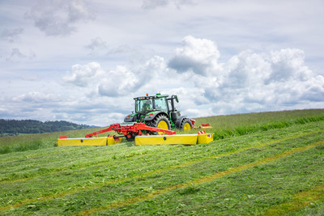 | 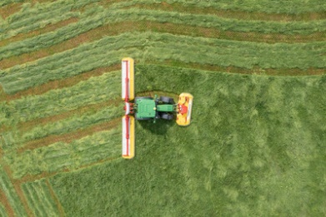
NOVACAT H 11200  delivers the best cutting quality | The NOVACAT F 3100 OC, NOVACAT H 11200mower combination impresses with its high output
https://www.poettinger.at/de_at/newsroom/pressebild/135623 | https://www.poettinger.at/de_at/newsroom/pressebild/135624

More printer-optimised photos: www.poettinger.at/presse

